How to submit an assignment:

Step 1: Login to BCS

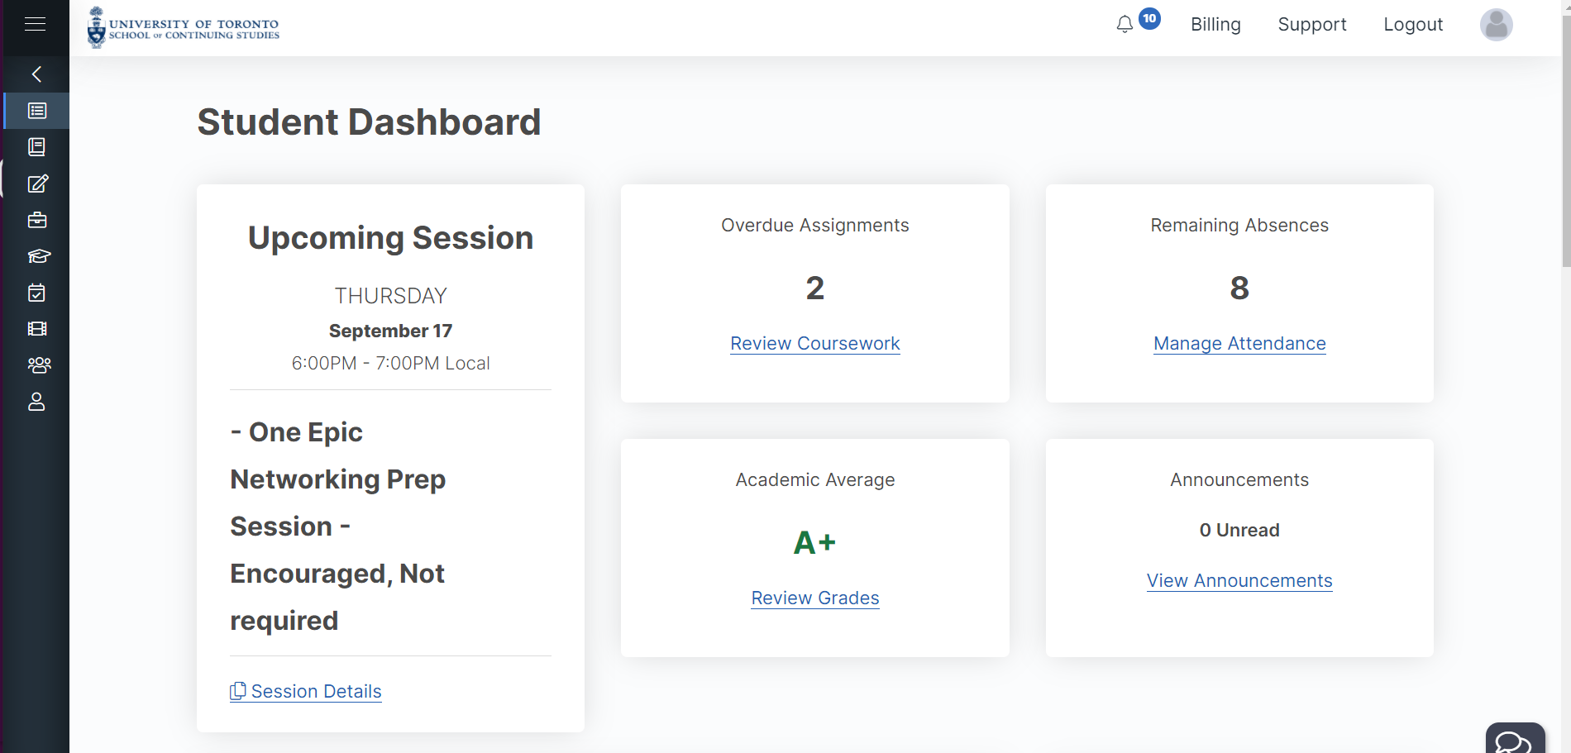

Step 2: On the left hand side, click the **coursework** button:

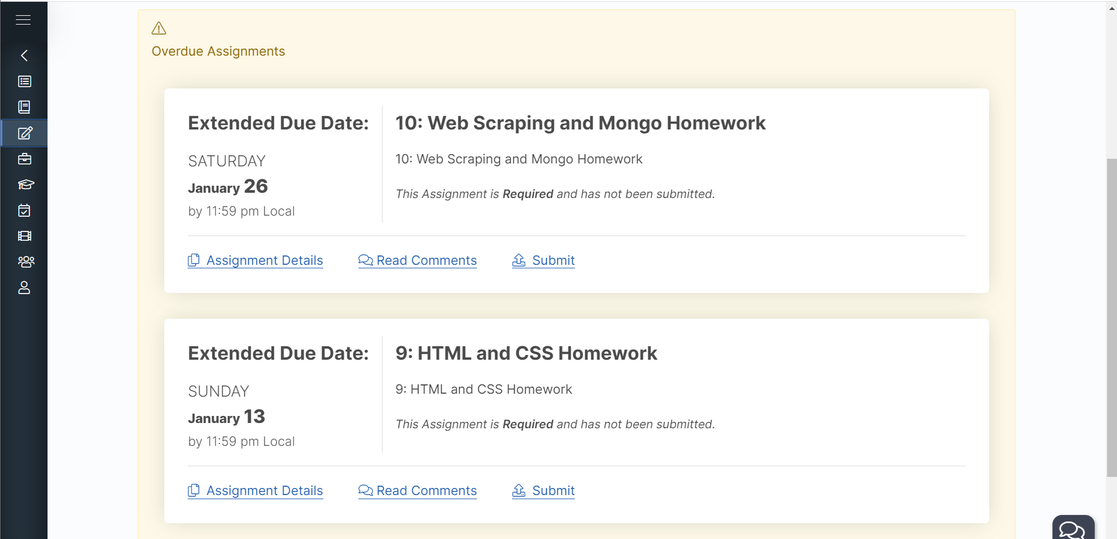

Step 3: Click the submit link for a relevant assignment:

Step 4: Attach your github repo url and **don’t forget to hit submit your coursework!**

